**RIYA INDAP,44**

~ping

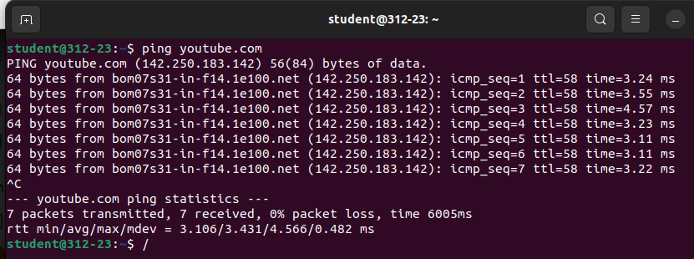

Ping command is a tool for testing connectivity and scalability

~traceroute

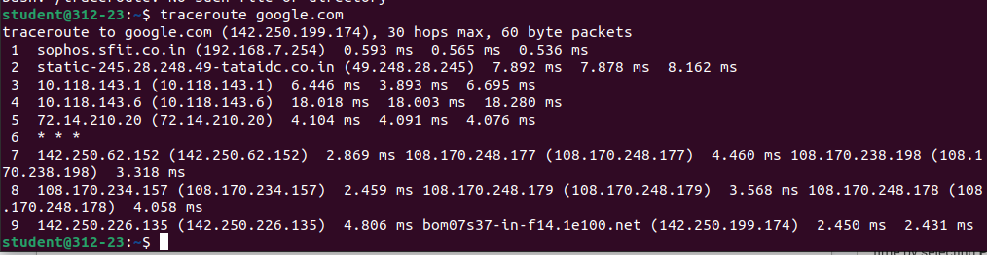

traceroute works by sending Internet Control Message Protocol (ICMP) packets, and every router involved in transferring the data gets these packets.

~netstat

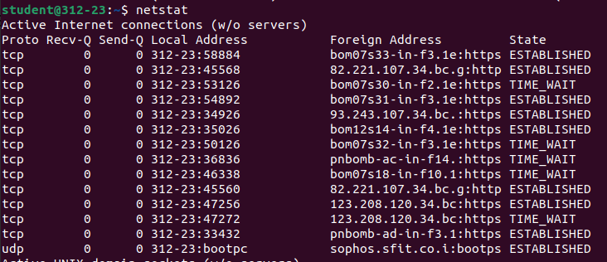

netstat command is a networking tool used for troubleshooting and configuration, that can also serve as a monitoring tool for connections over the network.

~ifconfig

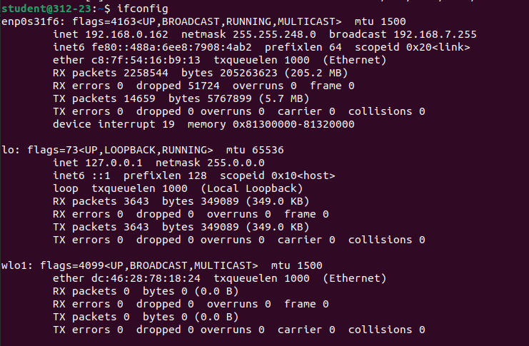

ifconfig function displays the current configuration for a network interface when no optional parameters are supplied.

~nslookup

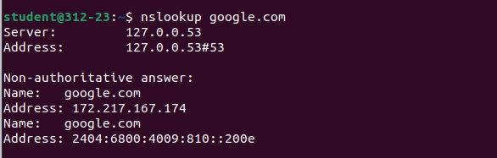

Nslookup command is a network administration tool for querying the Domain Name System (DNS) to obtain domain name or IP address mapping or any other specific DNS record.

~sudo tcpdump

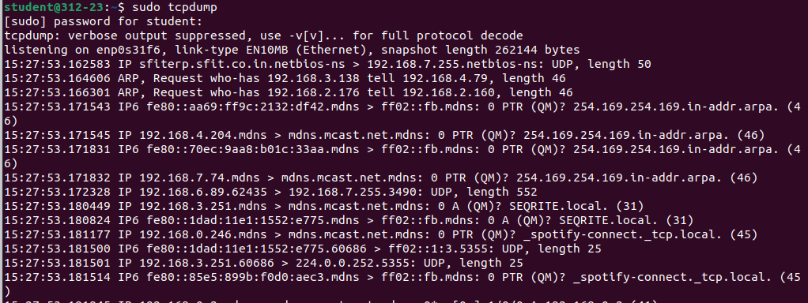

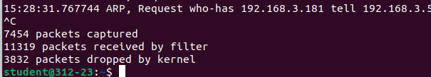

Used to analyze network traffic by intercepting and displaying packets that are being created or received by the computer it's running on.

~hostname



This command gives hostname of the computer.

~hostnamectl





Changes the hostname of the computer.

~whois

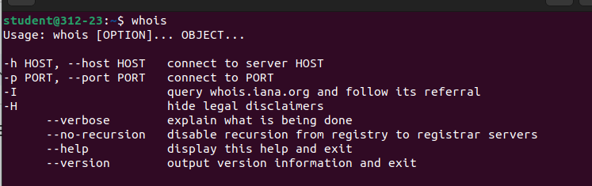

Command is a utility for retrieving information about a domain or an IP address.

**~POST_EXPERIMENT**

~dig

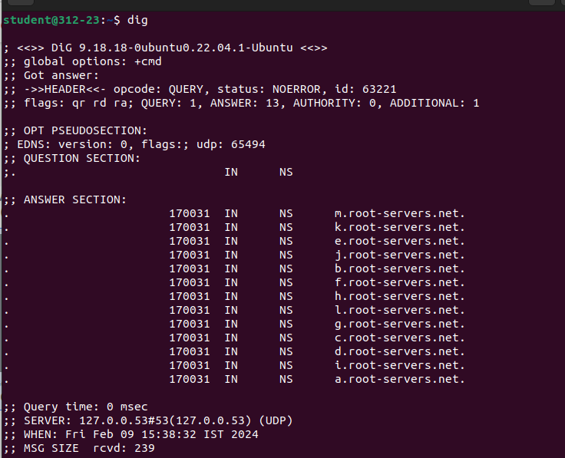

performs DNS lookup by querying name servers and displaying the result to you.

~route

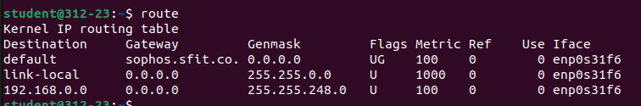

The route command is the interface used to access the Linux kernel's routing tables.

~host

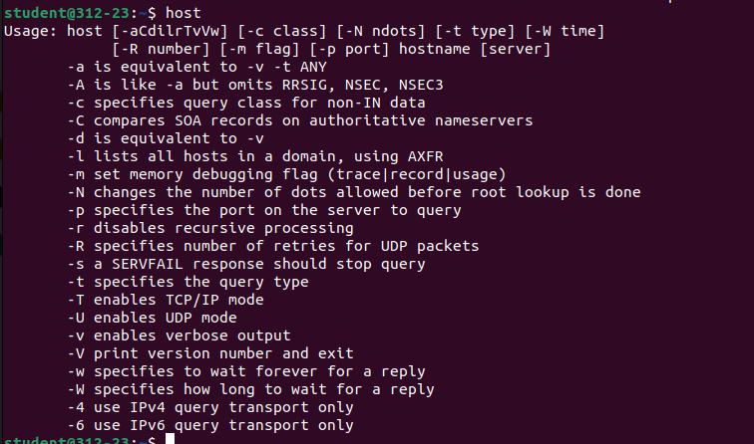

The host command is a command-line tool that performs DNS (Domain Name System) lookups

~arp

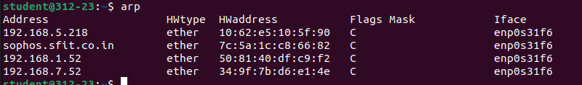

handles the mapping between an Internet Protocol (IP) address and a Media Access Control (MAC) address.

~mtr  
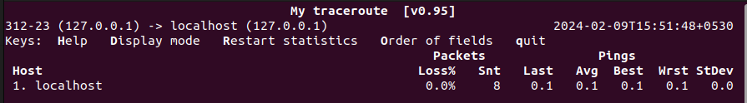

mtr is a networking tool that combines ping and traceroute to diagnose a network.